Appeal & Disposition User Manual

A step by step navigational process

November 2013

Prepared by: FEi Systems

Contents

1 Accessing Appeal & Disposition 1

2 Appeal 2

2.1 Add Appeal 2

2.2 Discard Appeal 4

3 Disposition 5

3.1 Add Disposition 5

3.2 Discard Disposition 7

# Accessing Appeal & Disposition

To access Appeal & Disposition, you must login as a permitted user:

1. Log in as the permitted user
2. Search for client under *Clients* tab using “**Case**” search
3. Click **Client Summary** for client

1. Enter client information and click "Cases" button
2. Click "Client Summary" link

1. Click **Program – Appeals & Disposition** from left navigation

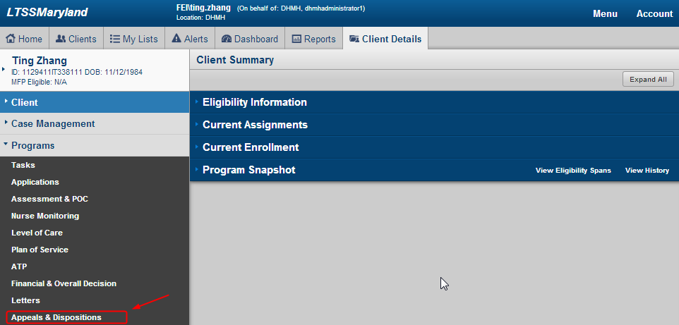

1. LTSS will bring you to Appeals and Dispositions – Appeals List page. To view summary of an appeal, click “Summary” link of the record

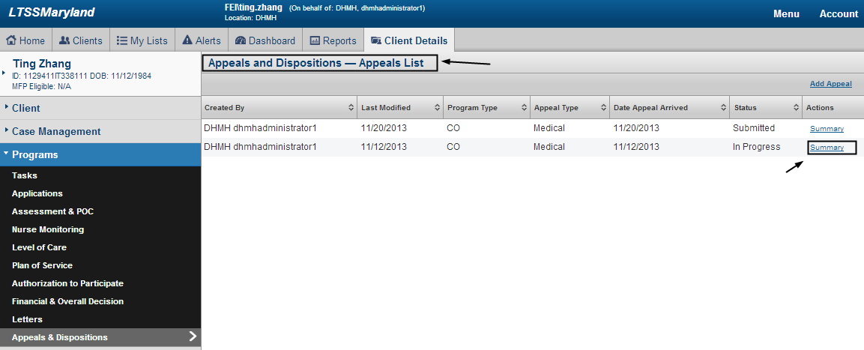

# Appeal

## Add Appeal

To add an Appeal, you must login as a permitted user.

1. Access Appeal & Disposition
2. Click “Add Appeal”

Access Appeal & Disposition and Click “Add Appeal”


1. LTSS will prompt user to select program type. Select program type and click “OK” to continue. You can also click “Cancel” to cancel

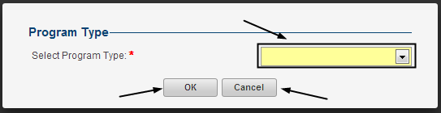

1. Complete appeal form and click “save”

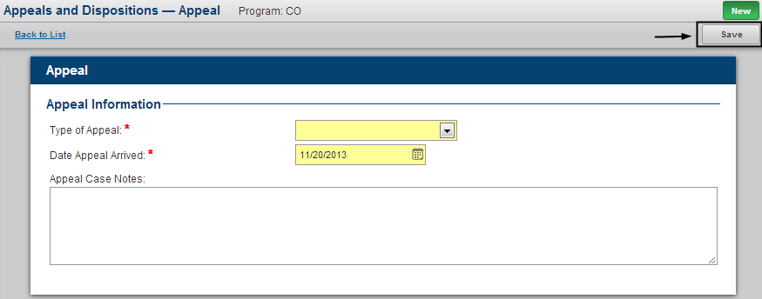

1. Please note that if client is currently “Dis-enrolled” from selected program, you will be asked to answer if client need to continue receiving service during appeal period

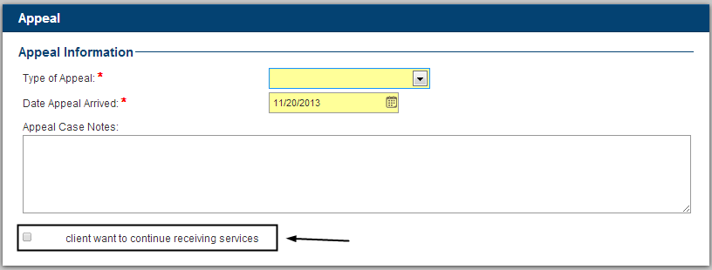

1. Then submit appeal form by clicking “Submit”

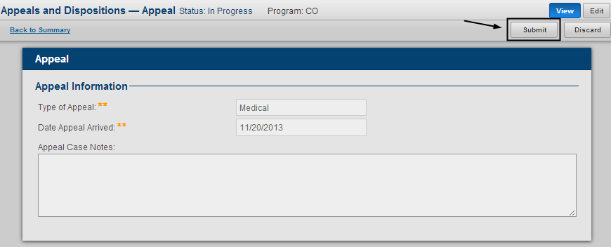

1. An new appeal is created

## Discard Appeal

To discard an Appeal, you must login as permitted user:

1. Access Appeal & Disposition
2. Select an Appeal and click “Summary”

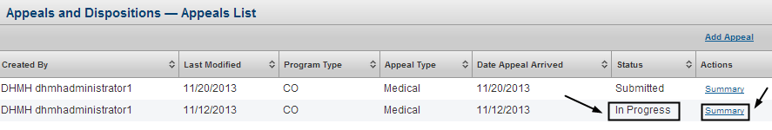

1. Click “View” from Appeal summary page

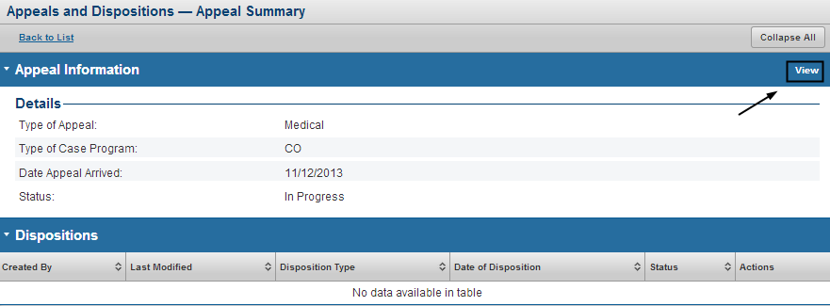

1. Click “Discard”

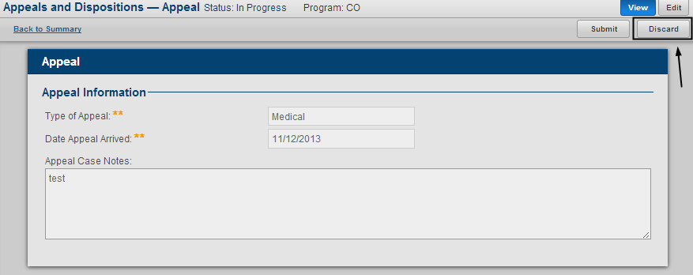

1. Enter “comments” and click “Yes” to complete discard, you can also click “No” to cancel

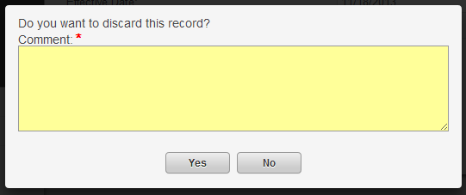

# Disposition

## Add Disposition

To add a disposition, you must login as a permitted user and choose a **submitted** appeal record

1. Access Appeal & Disposition
2. Select an submitted Appeal and click “Summary”

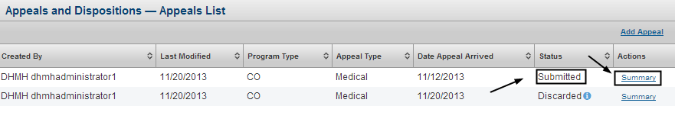

1. Click “Add” under “Disposition” section

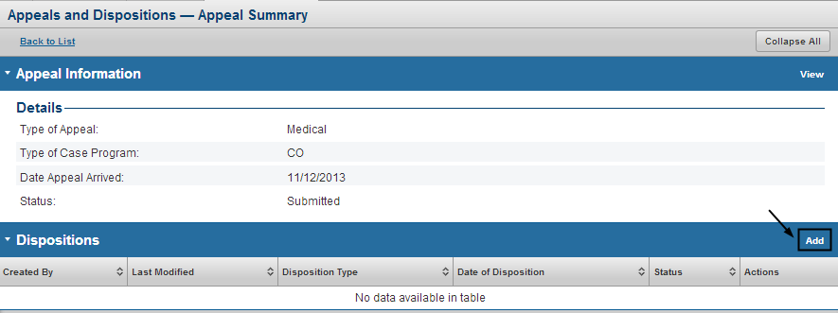

1. Complete disposition form and click “save”

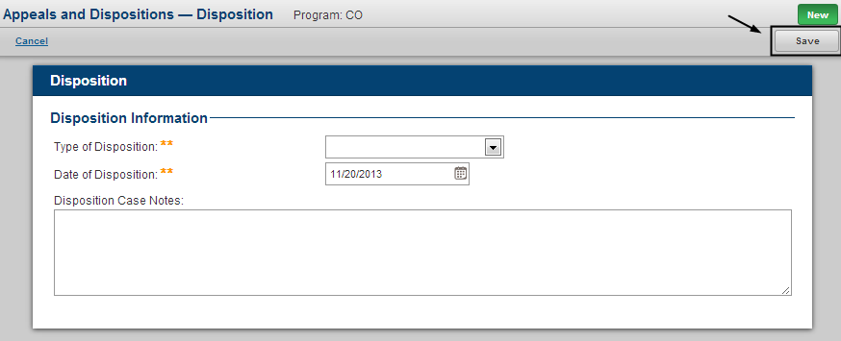

1. Then submit disposition form by clicking “Submit”

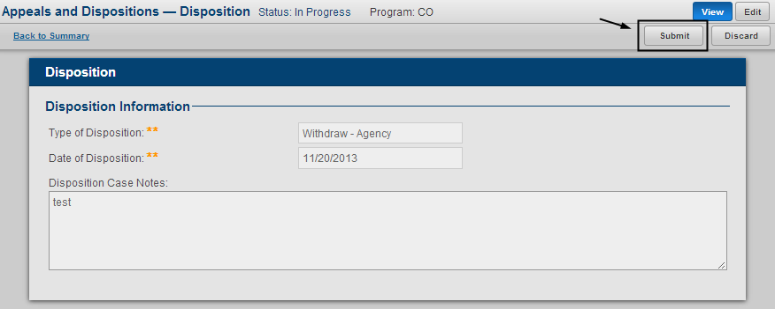

1. An new appeal is created

## Discard Disposition

To discard an Appeal, you must login as permitted user and select a submitted appeal record

1. Access Appeal & Disposition
2. Select an submitted Appeal and click “Summary”



1. Click “View” of the disposition record to be discarded

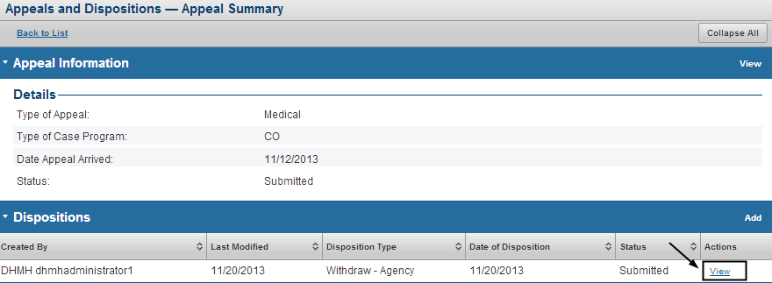

1. Click “Discard”

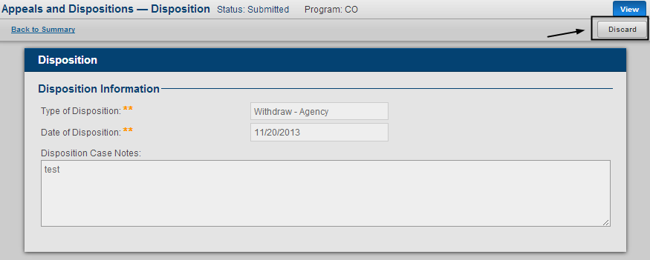

1. Enter “comments” and click “Yes” to complete discard, you can also click “No” to cancel

